Group Low Fidelity Prototype

*Shopping Saving Website  
-By The Trio*

# Image 1

## The Home Page

This is the home page for Shopping Savings website and it lets users to search grocery items, login to their account or sign up for a new account.

Links

1. Create shopping list
2. Sign up page

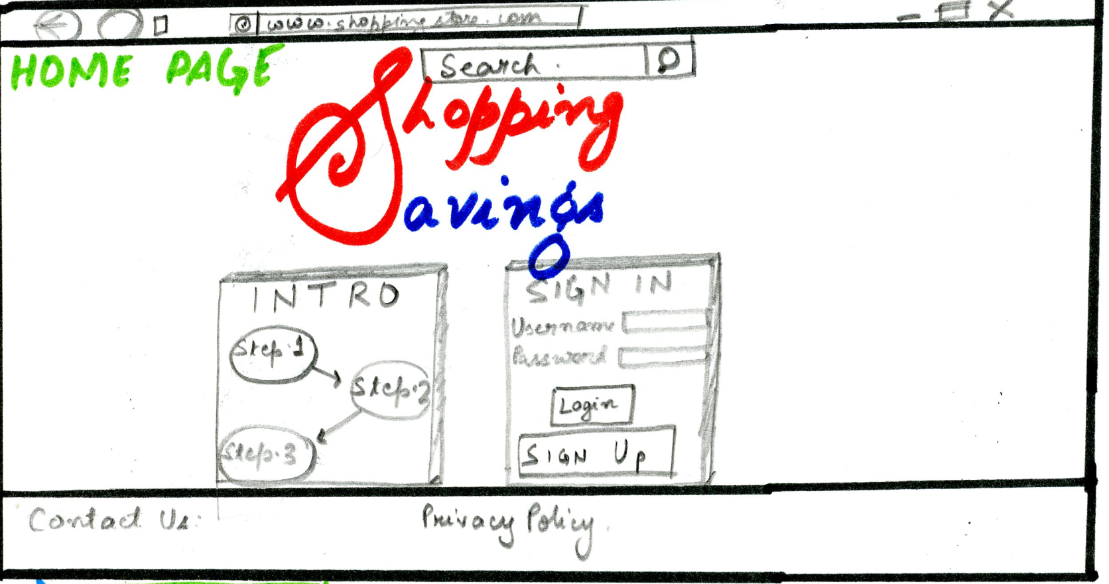

# Image 2

## Sign up page

In the sign up page the user is asked to input his name, email address and password. After he clicks register he is taken to login in home page.

Links:

1. Home page

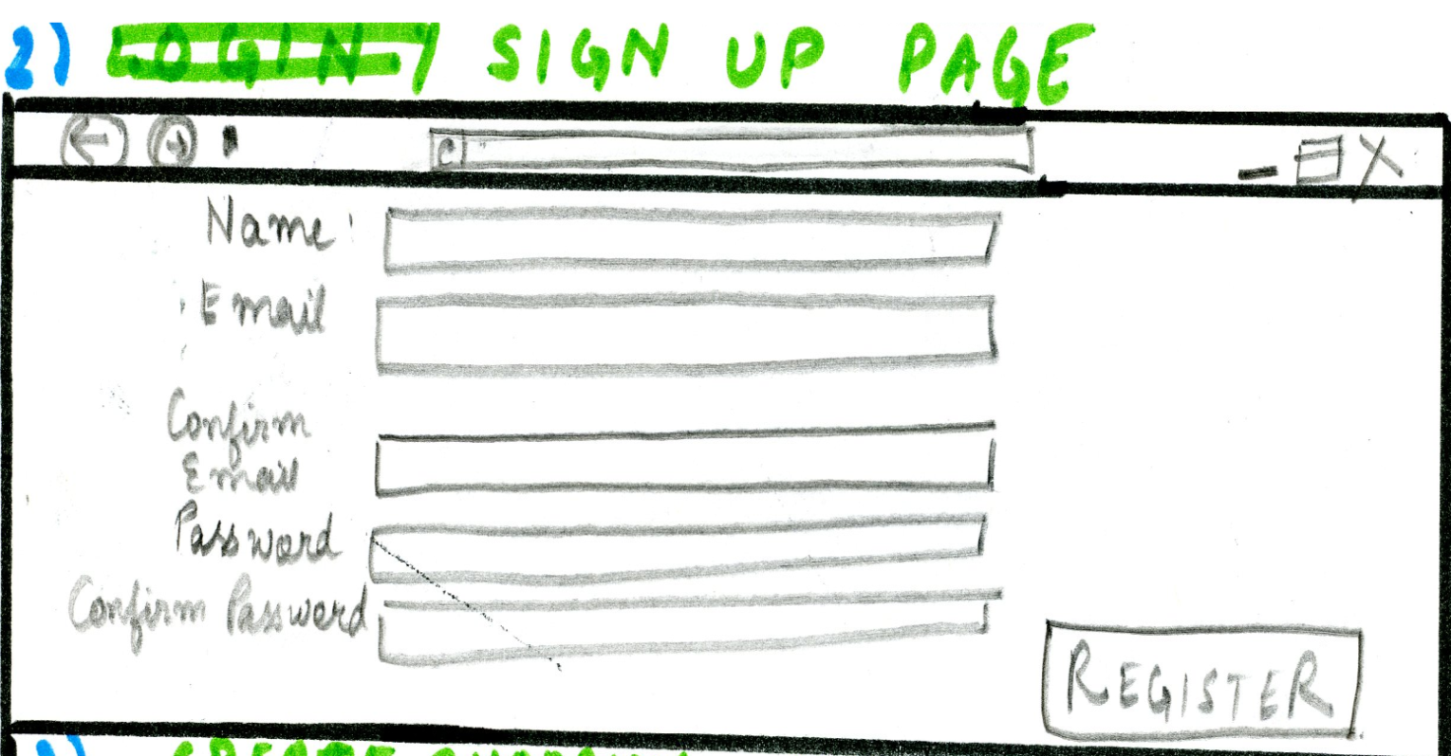

# Image 3

## Create Shopping List page

In this page the user can modify his previously created shopping list or create a new shopping list. He can select items he wants to buy by ticking on the list. The user is allowed to choose the different brands, quantity and amount in the drop down list. The compare price button will proceed to price comparison page.

Links:

1. 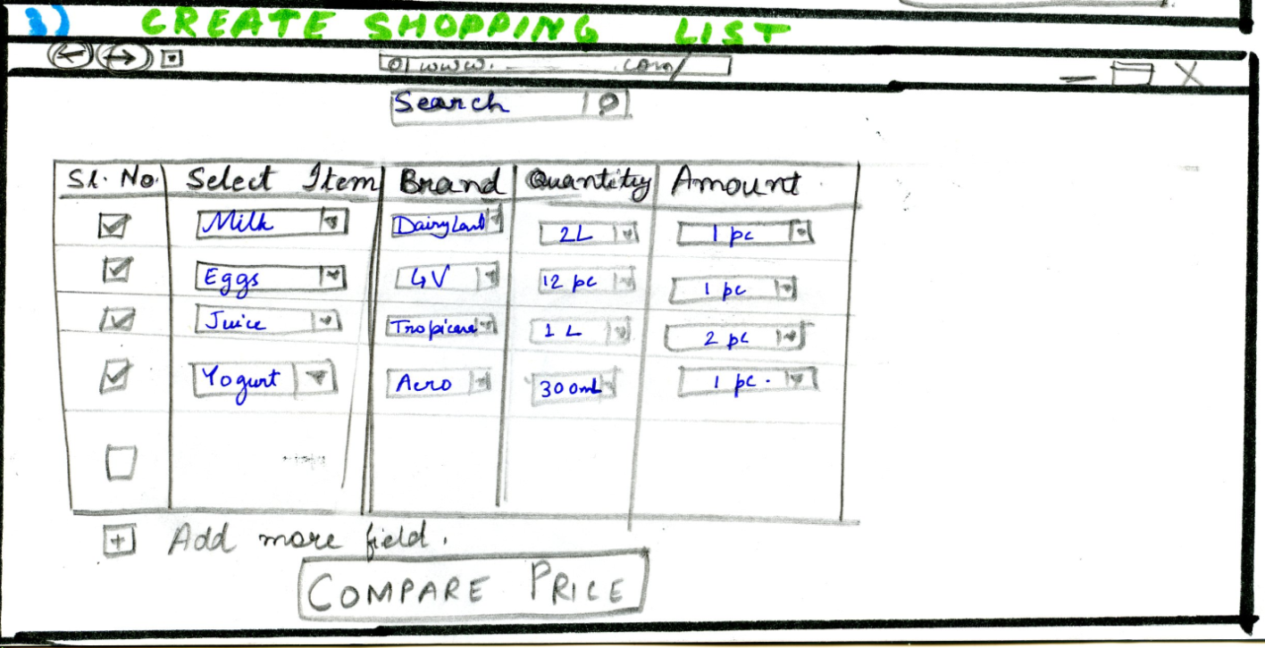Price comparison page

# Image 4

## Price comparison page

For each item the user selected, this page shows the prices at different stores. Total prices for all the items from different stores are shown at the bottom of the table. The user is allowed to select the cheapest store and proceed to purchase method page.

Links:

1. 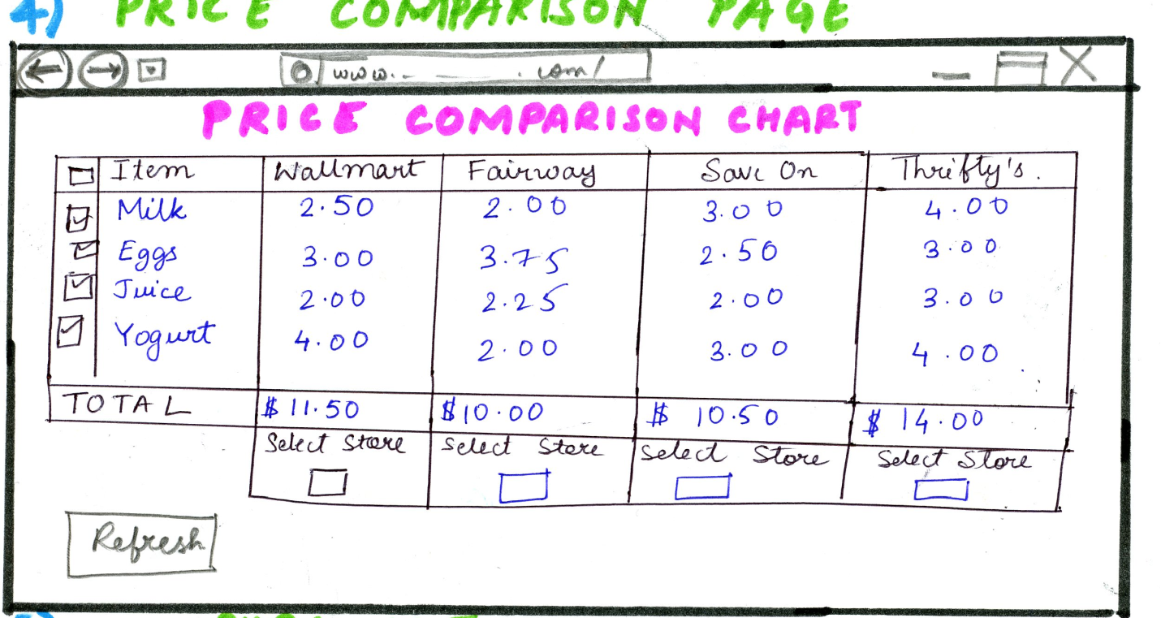Purchase Methods

# Image 5

## Purchase Method Page

There are two options to select in this page. One is pick up option and the other is delivery option. Links for this page are Pick up options page and Delivery page.

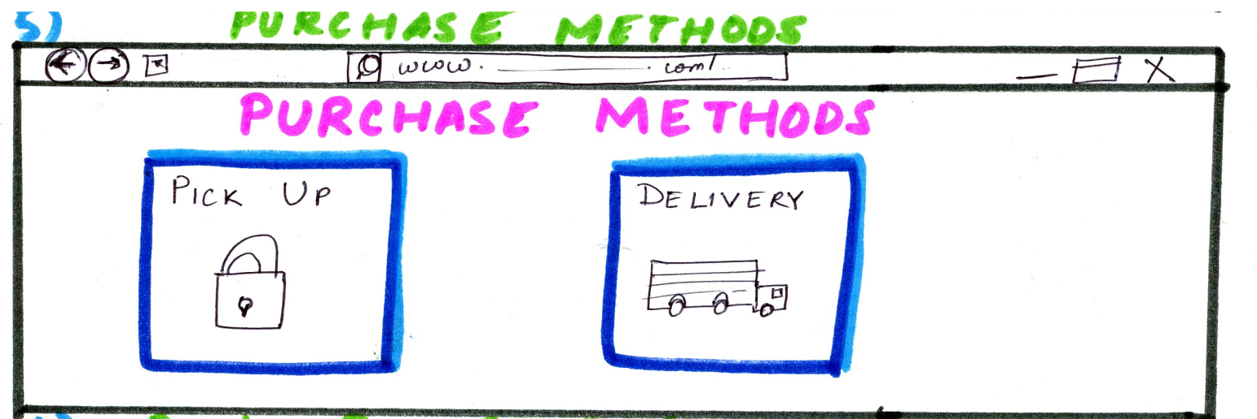

# Image 6

## Pick up options page

This page let user to select the province, city and enter postal code to locate the address. There is a map which shows the different location of the store and the location of the user. This page gives information on direction and store hours of the closest store for the user. If the user prefers home delivery he can click on home delivery button or proceed to payment page. The back button takes you to purchase method page.

Links:

1. Home delivery page
2. Payment page

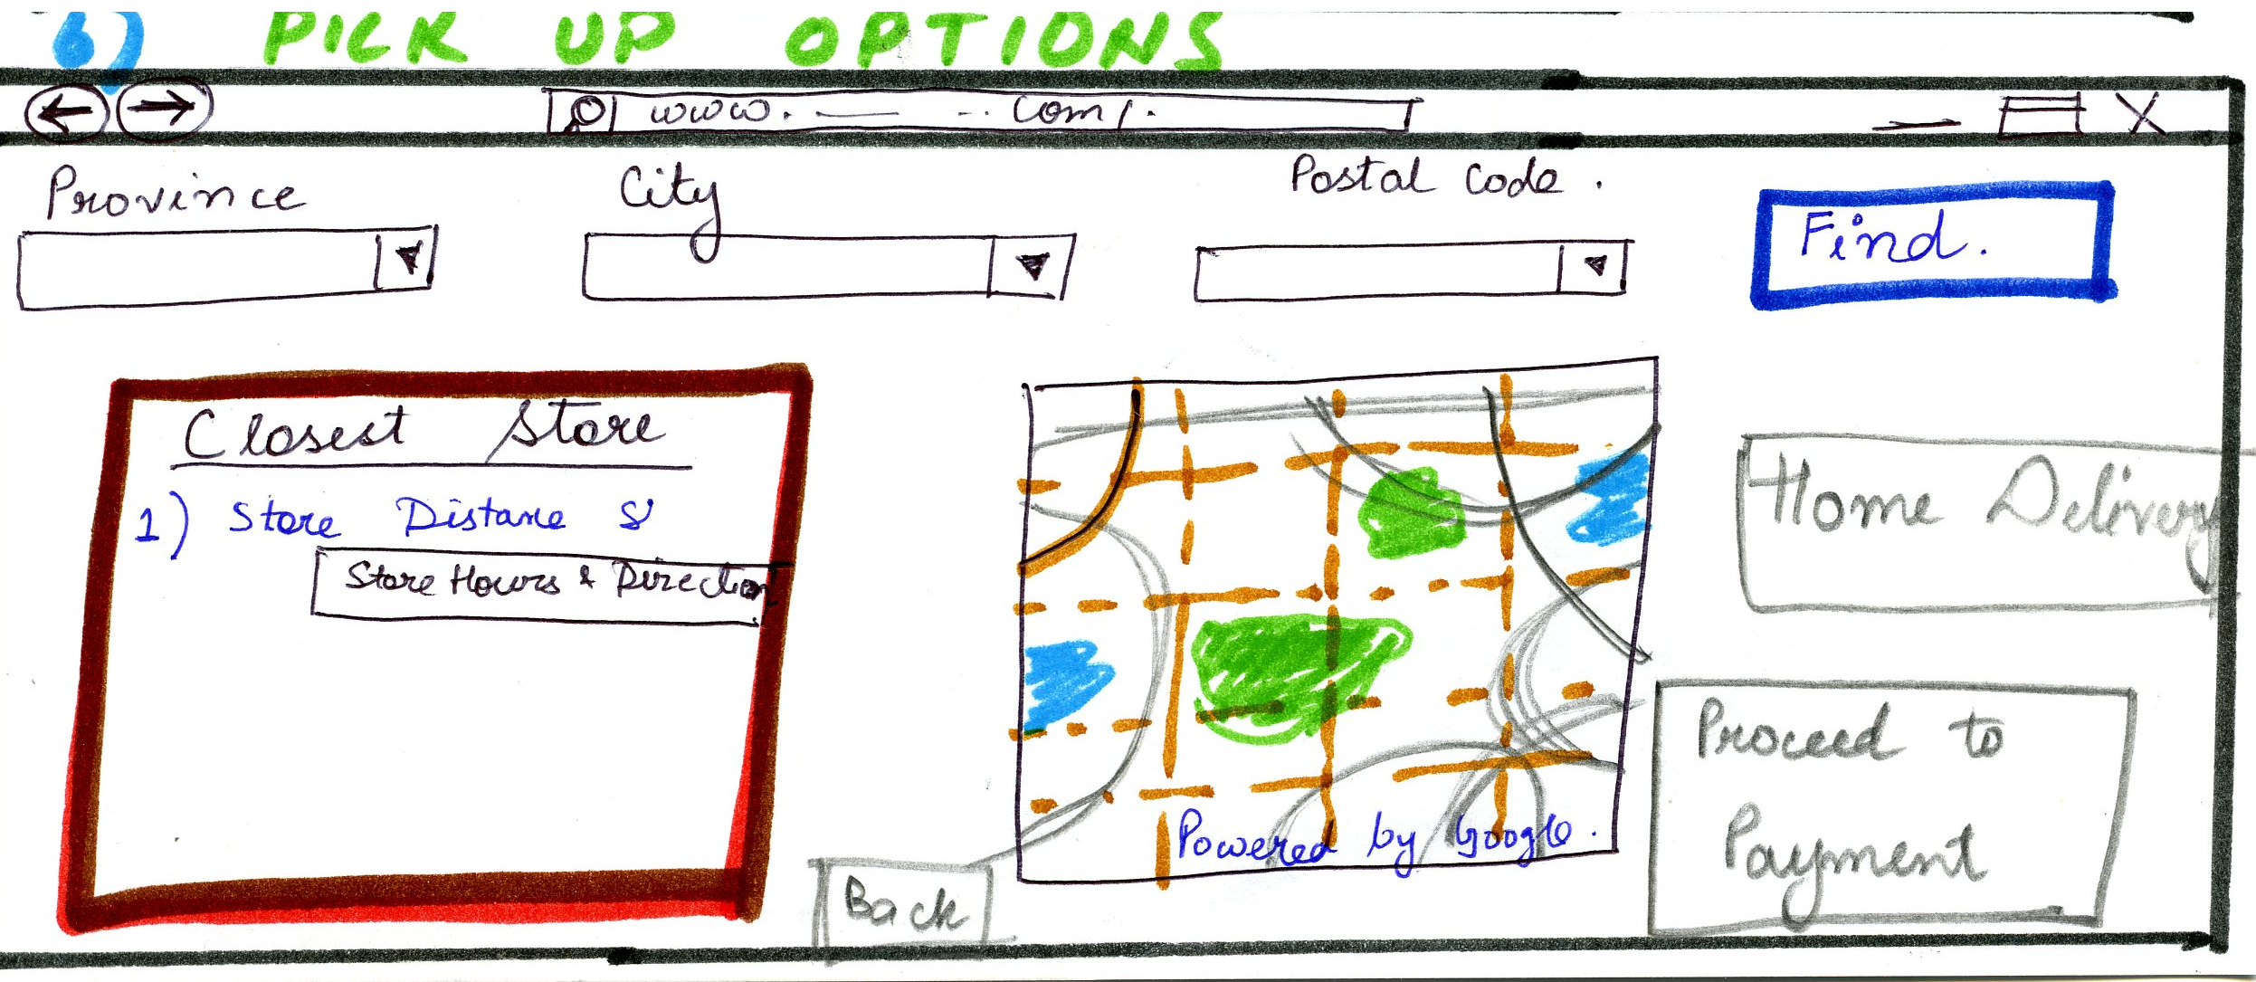

# Image 7

## Home Delivery page

In this page, the user needs to choose the location type, input address and is allowed mention any additional information regarding delivery. On the left side of the page the user is shown the address, store and time of delivery which can be changed. At the bottom of the page the Continue button takes user to the Payment Methods page.

Links

1. Payment Methods page

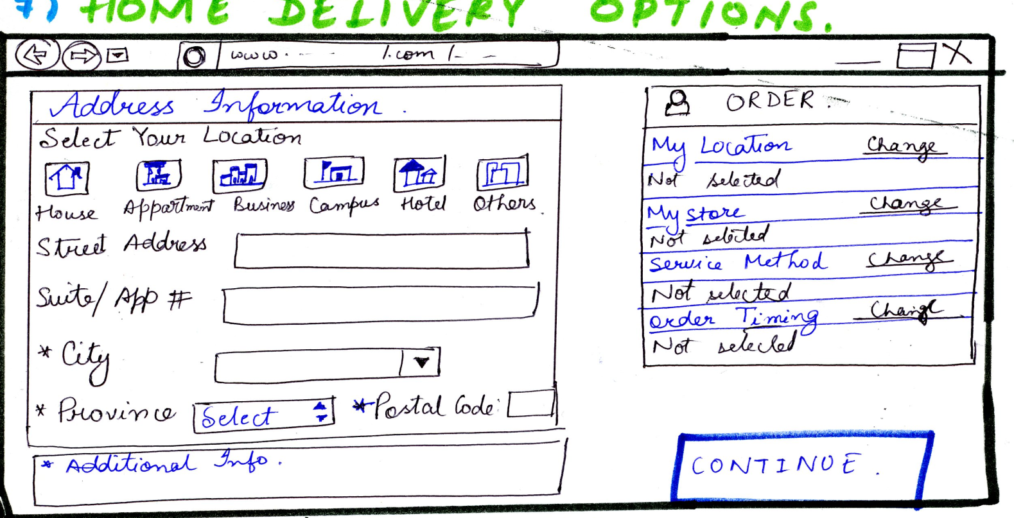

# Image 8

## Payment Methods page

This page shows the amount user need to pay for his items and different payment options. The radio buttons for Cash and Pay online is allowed to select. If it is by cash, the user can pay it at store or during delivery. If the user select online, he can choose either visa or MasterCard. After selecting the Confirm and Pay button, the user is taken to a different webpage depending on the type of card he uses for the payment. When the payment is processed and confirmed via Visa or MasterCard network, a confirmation page is displayed.

Links:

1. Visa network page/MasterCard network page
2. Confirmation page

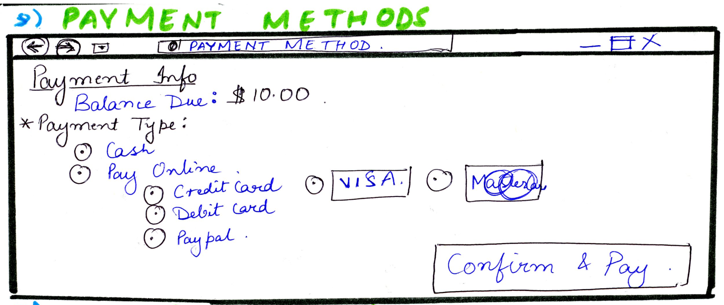

# Image 9

## Confirmation Page

This is the final page of the whole shopping process and this page displays a confirmation message saying that the user has successfully completed the payments a and receipt is displayed. The receipt can be shared, saved or printed. The finish button takes you back to the home page.

Links:

1. Homepage

